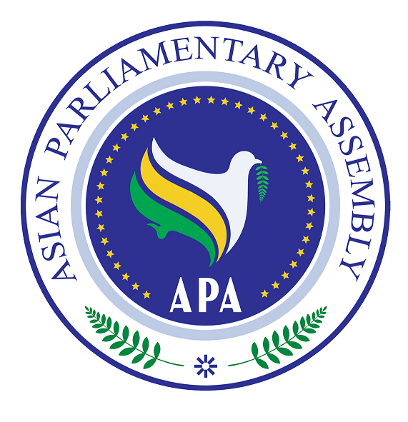

Asian Parliamentary Assembly Coordination Meeting
On the Sideline of the 140th IPU Assembly
Saturday, April 6, 2019-(09:30- 11:00) hours
Salwa 2, Sheraton Convention Center
Doha-Qatar

- Adoption of Agenda
- Opening Remark by the President of the Asian Parliamentary Assembly

- Report by H. E Dr. Mohammad Reza MAJIDI, APA Secretary General, on the APA activities since October 2018 and future programs scheduled for 2019.

- Consideration of emergency item,

- Any other business,

